Report of NSS activities (from December, 2019) to IQAC Cell, Govt. Khawzawl College
Sl.No. | Name of Organization | Date | Programme | Place/Venue | No. of Teachers Participated | No. of Students Participated
 | National Service Scheme | 4th November,2019 | Cleanliness Work | College Campus | 15 | 70
 | National Service Scheme | 14th – 15th November, 2019 | “Two Day Workshop on Challenges and Opportunities in NSS in Mizoram” | State Guest House and Tourist Lodge, Chaltlang, Aizawl, Mizoram | 1 | NIL
 | National Service Scheme | 24th January, 2020 | Cleanliness Work | Mualvawm Field, Khawzawl | 2 | 67
 | National Service Scheme | 25th – 31st January, 2020 | NSS Special Camping | Biate Town | 5 | 83
 | National Service Scheme | 2nd – 6th February, 2020 | NSS NE FESTIVAL | Manipur University, Imphal, Manipur. | NIL | 6 (M-3, F-3)
 | National Service Scheme | 5th May, 2020 | Data Collection (Knowledge about covid-19 is essential for surviving from the pandemic that prevails over the country. Govt. Khawzawl College, therefore is conducting a survey by using Questionnaire Method to study on the awareness of covid-19 among the local people and the preventive measures taken by them in order to stay safe. NSS Units of this College also give its contribution by collecting of data within Khawzawl Town) | Khawzawl City (Town) | 1 | 10
 | National Service Scheme | 15th May, 2020 | Cleanliness Work ( to clean the buildings selected for Quarantine Centre.) | JNV School, Khawzawl. | 1 | 55
 | National Service Scheme | 22nd May, 2020 | Cleanliness Work ( to clean the buildings selected for Quarantine Centre.) | Women Hostel Building, Govt. Khawzawl College | 4 | 20
 | National Service Scheme | 2nd June, 2020 | Meeting of NSS Programme Officers for the Observation of Green Mizoram day | Using ZOOM Apps | 1 | NIL
 | National Service Scheme | 12th June, 2020 | Training Cum Meeting of Programme Officers on Adoption of Village and Account Settlement | Using ZOOM Apps | 1 | NIL

(K. LALKULHPUIA)
Programme Officer
NSS, Govt. Khawzawl College

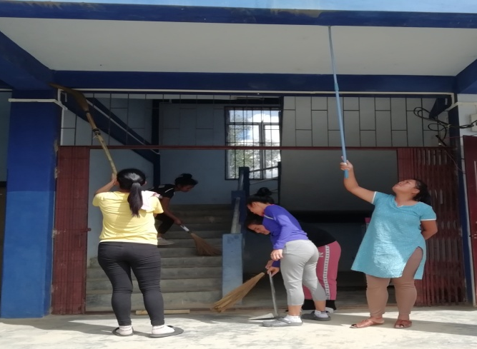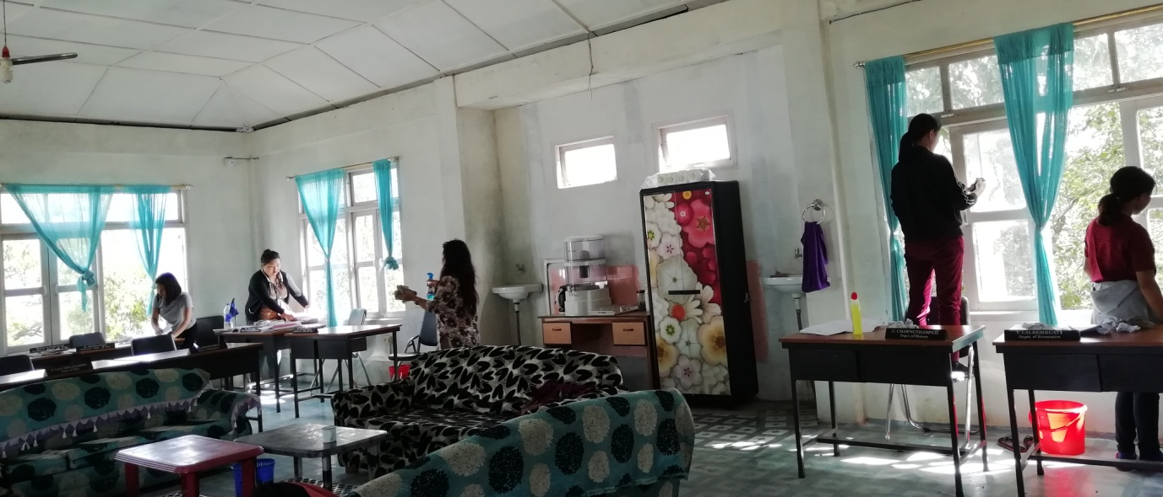
Cleanliness Work @ Campus on 4.11.2019

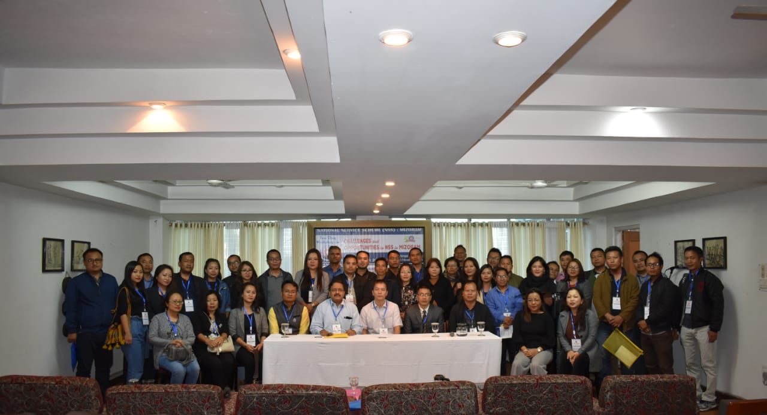
Two Days Workshop on 14-15.11.2020

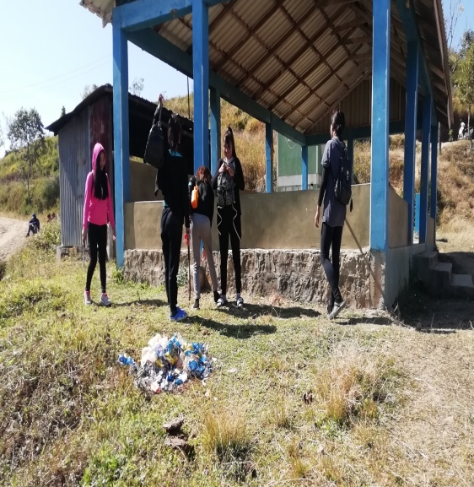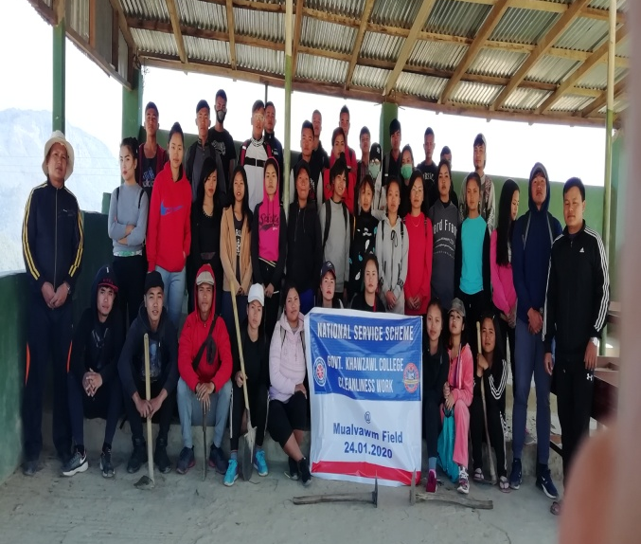
@ Mualvawm Field on 24.01.2020

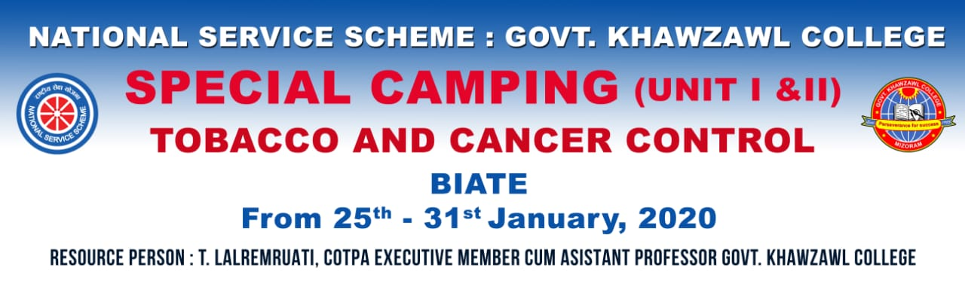
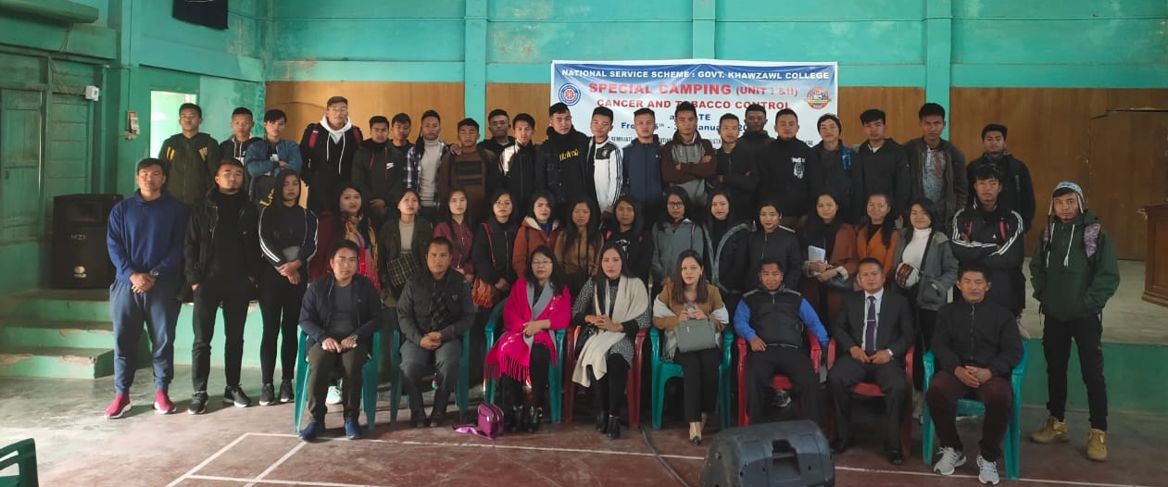
NSS Special Camping @ Biate from 25th – 31st January 2020
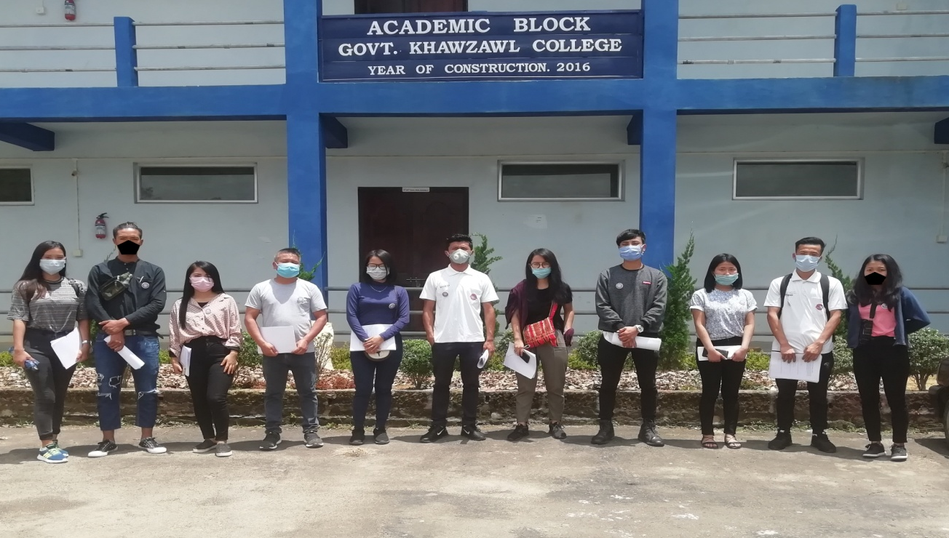
Questionnaire Data Collection on 05.05.2020
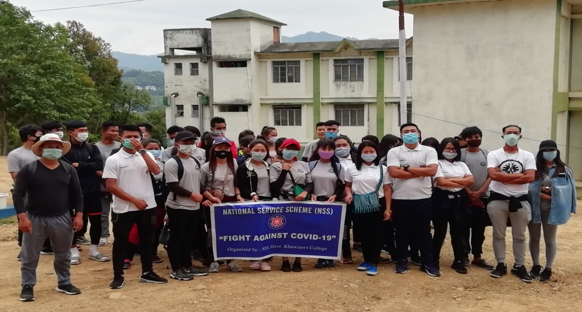
Cleaning of Quarantine Centre @ JNV School on 15.05.2020
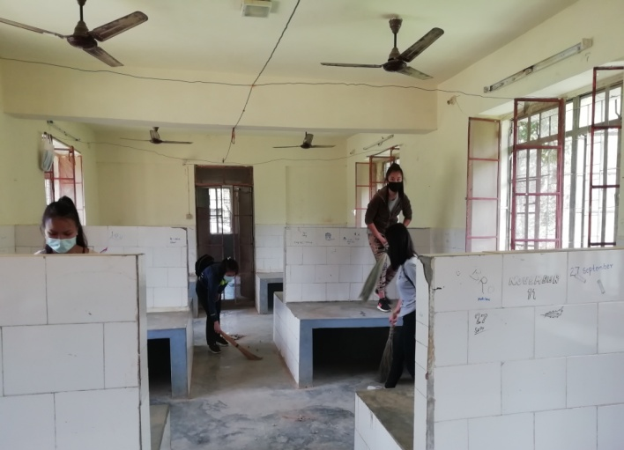
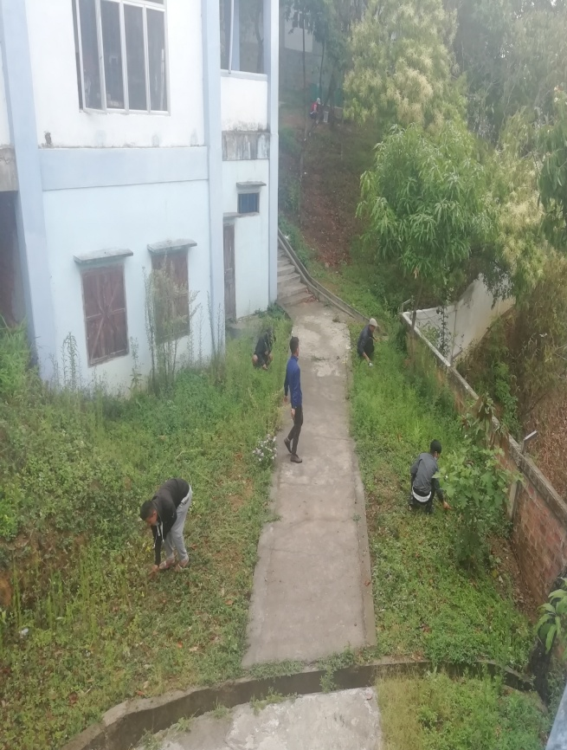
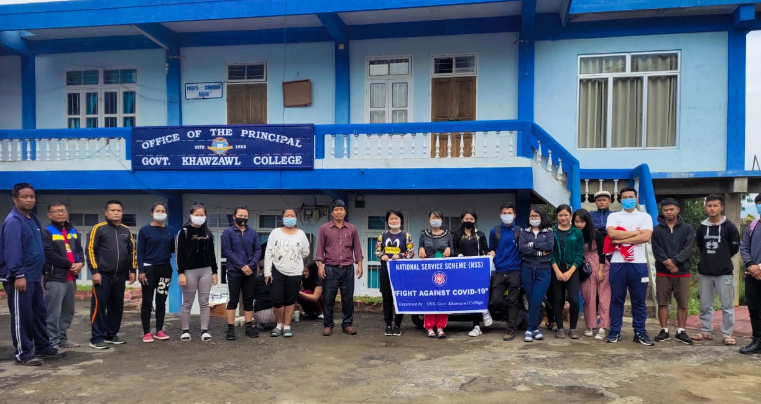
Cleaning of Quarantine Centre @ College on 22.05.2020

