To, Dated. 15th Sept. 2021
The Principal
Government Khawzawl College
Khawzawl : Mizoram

Subject : Submission of Internal Audit Report 2020-2021

Respected Sir,
I have the honour to submit the Internal Audit Report of the following Accounts for the period 1st July 2020- 30th June 2021.

- Institution accounts (without LOC)
- Accounts of Staff Welfare, Govt. Khawzawl College
- Accounts of RUSA PMU
- RUSA Main Account
- MCTA Account

Yours faithfully,

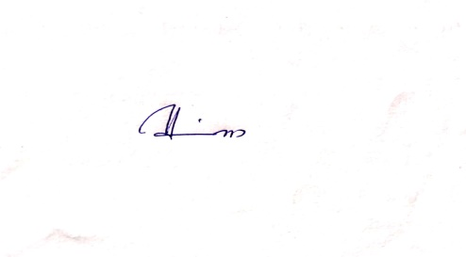
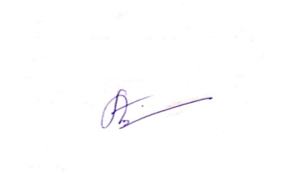
AUDITORS,

(R. LALTHANLIANA) (H. VANLALHRUAIA) (PC. LALRINDIKA)

GOVERNMENT KHAWZAWL COLLEGE
AUDIT REPORT FOR INSTITUTION ACCOUNT (Without LOC)

Audit Period : 1st July 2020 - 30th June 2021

On 17th October 2021 Institution Account is audited. Present statement of Account is stated below.

Opening Balance : Rs 6,31,898/-
Receipt during the period : Rs 9,75,339/-
Total : Rs 16,07,237/-
Total Expenditure : Rs 6,43,520/-
Closing Balance : Rs 9,63,717/-

AUDITORS,

(R. LALTHANLIANA) (H. VANLALHRUAIA) (PC. LALRINDIKA)

GOVERNMENT KHAWZAWL COLLEGE
AUDIT REPORT FOR STAFF WELFARE ACCOUNT

Audit Period : 1st July 2020 - 30th June 2021

On 17th October 2021 Staff Welfare Account is audited. Present statement of Account is stated below.

Opening Balance : Rs 2,16,775/-
Receipt during the period : Rs 3,42,700/-
Total : Rs 5,59,475/-
Total Expenditure : Rs 3,68,000/-
Closing Balance : Rs 1,91,475/-

AUDITORS,

(R. LALTHANLIANA) (H. VANLALHRUAIA) (PC. LALRINDIKA)
GOVERNMENT KHAWZAWL COLLEGE
AUDIT REPORT FOR RUSA PMU ACCOUNT

Audit Period : 1st July 2020 - 30th June 2021

On 17th October 2021 RUSA PMU Account is audited. Present statement of Account is stated below.

Opening Balance : Rs 6,48,593/-
Receipt during the period : Rs 1,04,000/-
Total : Rs 752,593/-
Total Expenditure : Rs 2,33,560/-
Closing Balance : Rs 5,19,033/-

AUDITORS,

(R. LALTHANLIANA) (H. VANLALHRUAIA) (PC. LALRINDIKA)
GOVERNMENT KHAWZAWL COLLEGE
AUDIT REPORT FOR RUSA MAIN ACCOUNT

Audit Period : 1st July 2020 - 27th Sept 2021

On 17th October 2021 RUSA Main Account is audited. Present statement of Account is stated below.

Opening Balance : Rs 24,72,157/-
Receipt during the period : Rs 50,84,037/-
Total : Rs 75,56,194/-
Total Expenditure : Rs 75,56,194/-
Closing Balance : Rs 10/-

AUDITORS,

(R. LALTHANLIANA) (H. VANLALHRUAIA) (PC. LALRINDIKA)
GOVERNMENT KHAWZAWL COLLEGE
AUDIT REPORT FOR MCTA ACCOUNT

Audit Period : 1st July 2020 - 30th June 2021

On 17th October 2021 MCTA Account is audited. Present statement of Account is stated below.

CASH BANK TOTAL
Opening Balance : Rs - 98,374 98,374
Receipt during the period : Rs 55,000 28,180 83,180
Total : Rs 55,000 1,26,554 1,81,554
Total Expenditure : Rs 29,480 1,05,689 1,35,169
Closing Balance : Rs 25,520 20,865 46,385

AUDITORS,

(R. LALTHANLIANA) (H. VANLALHRUAIA) (PC. LALRINDIKA)
AUDIT OBSERVATIONS AND SUGGESTIONS

We have conducted our audit in accordance with auditing standards generally accepted in India. Prudent calculation and system of correct & check are employed to see that financial statements are free from material mis-statements.

Based on our Audit, We report that:

- Accounts be closed henceforth on 30th June every year (i.e. 1st July – 30th June)
- Receipt and Expenditure for the year (i.e. 1st July – 30th June) be summed up and be reflected clearly along with Closing Balance.
- Immediately after the Account closing page every year, one Blank page should be left for Audit Note writing.

AUDITORS,

(R. LALTHANLIANA) (H. VANLALHRUAIA) (PC. LALRINDIKA)

